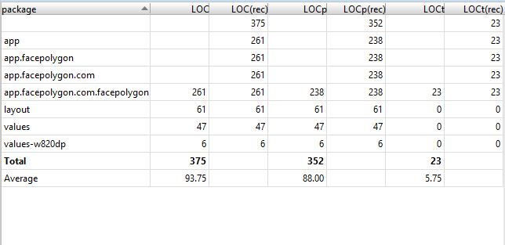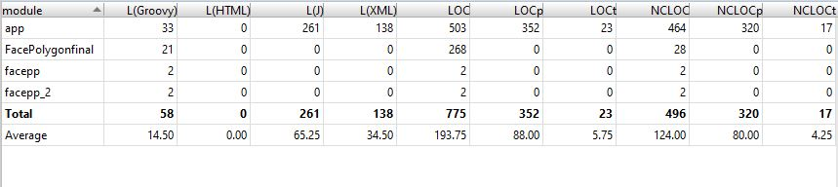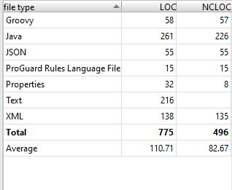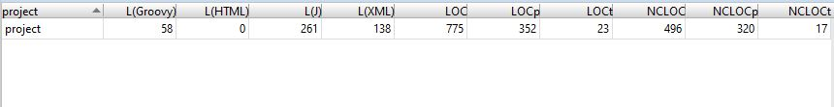

**package** com.facpp.picturedetect;  
  
**import** java.io.ByteArrayOutputStream;  
  
**import** android.app.Activity;  
**import** android.content.Intent;  
**import** android.database.Cursor;  
**import** android.graphics.Bitmap;  
**import** android.graphics.BitmapFactory;  
**import** android.graphics.BitmapFactory.Options;  
**import** android.graphics.Canvas;  
**import** android.graphics.Color;  
**import** android.graphics.Matrix;  
**import** android.graphics.Paint;  
**import** android.net.Uri;  
**import** android.os.Bundle;  
**import** android.provider.MediaStore.Images.ImageColumns;  
**import** android.util.Log;  
**import** android.view.Menu;  
**import** android.view.View;  
**import** android.view.View.OnClickListener;  
**import** android.widget.Button;  
**import** android.widget.ImageView;  
**import** android.widget.TextView;  
  
**import** com.facepp.error.FaceppParseException;  
**import** com.facepp.http.HttpRequests;  
**import** com.facepp.http.PostParameters;  
**import** com.facepp.result.FaceppResult;  
**import** com.google.android.gms.appindexing.Action;  
**import** com.google.android.gms.appindexing.AppIndex;  
**import** com.google.android.gms.common.api.GoogleApiClient;  
  
**import** app.facepolygon.com.facepolygon.FaceppResult;  
**import** app.facepolygon.com.facepolygon.R;  
  
*/**  
 * A simple demo, get a picture form your phone<br />  
 * Use the facepp api to detect<br />  
 * Find all face on the picture, and mark them out.  
 *  
 \** ***@author*** *moon5ckq  
 */***public class** MainActivity **extends** Activity {  
  
 **final private static** String ***TAG*** = **"MainActivity"**;  
 **final private int PICTURE_CHOOSE** = 1;  
  
 **private** ImageView **imageView** = **null**;  
 **private** Bitmap **img** = **null**;  
 **private** Button **buttonDetect** = **null**;  
 **private** TextView **textView** = **null**;  
 */**  
 * ATTENTION: This was auto-generated to implement the App Indexing API.  
 * See https://g.co/AppIndexing/AndroidStudio for more information.  
 */* **private** GoogleApiClient **client**;  
  
  
 @Override  
 **public void** onCreate(Bundle savedInstanceState) {  
 **super**.onCreate(savedInstanceState);  
 setContentView(R.layout.***activity_main***);  
  
 Button button = (Button) **this**.findViewById(R.id.***button1***);  
 button.setOnClickListener(**new** OnClickListener() {  
  
 **public void** onClick(View arg0) {  
 *//get a picture form your phone* Intent photoPickerIntent = **new** Intent(Intent.***ACTION_PICK***);  
 photoPickerIntent.setType(**"image/*"**);  
 startActivityForResult(photoPickerIntent, **PICTURE_CHOOSE**);  
 }  
 });  
  
 **textView** = (TextView) **this**.findViewById(R.id.***textView1***);  
  
 **buttonDetect** = (Button) **this**.findViewById(R.id.***button2***);  
 **buttonDetect**.setVisibility(View.***INVISIBLE***);  
 **buttonDetect**.setOnClickListener(**new** OnClickListener() {  
 **public void** onClick(View arg0) {  
  
 **textView**.setText(**"Waiting ..."**);  
  
 *// FaceppDetect faceppDetect = new FaceppDetect();  
 //faceppDetect.setDetectCallback(new DetectCallback() {* **public void** detectResult(FaceppResult rst) {  
 *//Log.v(TAG, rst.toString());  
  
 //use the red paint* Paint paint = **new** Paint();  
 paint.setColor(Color.***RED***);  
 paint.setStrokeWidth(Math.*max*(**img**.getWidth(), **img**.getHeight()) / 100f);  
  
 *//create a new canvas* Bitmap bitmap = Bitmap.*createBitmap*(**img**.getWidth(), **img**.getHeight(), **img**.getConfig());  
 Canvas canvas = **new** Canvas(bitmap);  
 canvas.drawBitmap(**img**, **new** Matrix(), **null**);  
  
  
 **try** {  
 *//find out all faces* **final int** count = rst.get.(**"face"**).getCount();  
 **for** (**int** i = 0; i < count; ++i) {  
 **float** x, y, w, h;  
 *//get the center point* x = (**float**) rst.set(**"face"**).get(i).get(**"center"**).get(**"x"**).toDouble().doubleValue();  
 y = (**float**) rst.set(**"face"**).get(i).get(**"center"**).get(**"y"**).toDouble().doubleValue();  
  
 *//get face size* w = (**float**) rst.get(**"face"**).get(i).get(**"width"**).toDouble().doubleValue();  
 h = (**float**) rst.get(**"face"**).get(i).get(**"height"**).toDouble().doubleValue();  
  
 *//change percent value to the real size* x = x / 100 * **img**.getWidth();  
 w = w / 100 * **img**.getWidth() * 0.7f;  
 y = y / 100 * **img**.getHeight();  
 h = h / 100 * **img**.getHeight() * 0.7f;  
  
 *//draw the box to mark it out* canvas.drawLine(x - w, y - h, x - w, y + h, paint);  
 canvas.drawLine(x - w, y - h, x + w, y - h, paint);  
 canvas.drawLine(x + w, y + h, x - w, y + h, paint);  
 canvas.drawLine(x + w, y + h, x + w, y - h, paint);  
 }  
  
 *//save new image* **img** = bitmap;  
  
 MainActivity.**this**.runOnUiThread(**new** Runnable() {  
  
 **public void** run() {  
 *//show the image* **imageView**.setImageBitmap(**img**);  
 **textView**.setText(**"Finished, "** + count + **" faces."**);  
 }  
 });  
  
 } **catch** (FaceppParseException e) {  
 e.printStackTrace();  
  
 MainActivity.**this**.runOnUiThread(**new** Runnable() {  
 **public void** run() {  
 **textView**.setText(**"Error."**);  
 }  
 });  
 }  
  
 }  
 });  
 *// faceppDetect.detect(img);* }  
 *// ATTENTION: This was auto-generated to implement the App Indexing API.  
 // See https://g.co/AppIndexing/AndroidStudio for more information.* **client** = **new** GoogleApiClient.Builder(**this**).addApi(AppIndex.***API***).build();  
 }  
  
 );  
  
 **imageView**=(ImageView)**this**.  
  
 findViewById(R.id.***imageView1***);  
  
 **imageView**.setImageBitmap(**img**);  
}  
  
  
 @Override  
 **protected void** onActivityResult(**int** requestCode, **int** resultCode, Intent intent) {  
 **super**.onActivityResult(requestCode, resultCode, intent);  
  
 *//the image picker callback* **if** (requestCode == **PICTURE_CHOOSE**) {  
 **if** (intent != **null**) {  
 *//The Android api ~~~  
 //Log.d(TAG, "idButSelPic Photopicker: " + intent.getDataString());* Cursor cursor = getContentResolver().query(intent.getData(), **null**, **null**, **null**, **null**);  
 cursor.moveToFirst();  
 **int** idx = cursor.getColumnIndex(ImageColumns.***DATA***);  
 String fileSrc = cursor.getString(idx);  
 *//Log.d(TAG, "Picture:" + fileSrc);  
  
 //just read size* Options options = **new** Options();  
 options.**inJustDecodeBounds** = **true**;  
 **img** = BitmapFactory.*decodeFile*(fileSrc, options);  
  
 *//scale size to read* options.**inSampleSize** = Math.*max*(1, (**int**) Math.*ceil*(Math.*max*((**double**) options.**outWidth** / 1024f, (**double**) options.**outHeight** / 1024f)));  
 options.**inJustDecodeBounds** = **false**;  
 **img** = BitmapFactory.*decodeFile*(fileSrc, options);  
 **textView**.setText(**"Clik Detect. ==>"**);  
  
  
 **imageView**.setImageBitmap(**img**);  
 **buttonDetect**.setVisibility(View.***VISIBLE***);  
 } **else** {  
 Log.*d*(***TAG***, **"idButSelPic Photopicker canceled"**);  
 }  
 }  
 }  
  
 */* private class FaceppDetect {  
 DetectCallback callback = null;  
  
 public void setDetectCallback(DetectCallback detectCallback) {  
 callback = detectCallback;  
 }*/* **public void** detect(**final** Bitmap image) {  
  
 **new** Thread(**new** Runnable() {  
  
 **public void** run() {  
 *// HttpRequests httpRequests = new HttpRequests("api_key", "api_secret");  
 //Log.v(TAG, "image size : " + img.getWidth() + " " + img.getHeight());* ByteArrayOutputStream stream = **new** ByteArrayOutputStream();  
 **float** scale = Math.*min*(1, Math.*min*(600f / **img**.getWidth(), 600f / **img**.getHeight()));  
 Matrix matrix = **new** Matrix();  
 matrix.postScale(scale, scale);  
  
 Bitmap imgSmall = Bitmap.*createBitmap*(**img**, 0, 0, **img**.getWidth(), **img**.getHeight(), matrix, **false**);  
 *//Log.v(TAG, "imgSmall size : " + imgSmall.getWidth() + " " + imgSmall.getHeight());* imgSmall.compress(Bitmap.CompressFormat.***JPEG***, 100, stream);  
 **byte**[] array = stream.toByteArray();  
  
 */* try {  
 //detect  
 // FaceppResult result = httpRequests.detectionDetect(new PostParameters().setImg(array));  
 //finished , then call the callback function  
 if (callback != null) {  
 callback.detectResult(result);  
 }  
 }/* catch (FaceppParseException e) {  
 e.printStackTrace();  
 MainActivity.this.runOnUiThread(new Runnable() {  
 public void run() {  
 textView.setText("Network error.");  
 }  
 });  
 }*/* }  
 }).start();  
 }  
  
 @Override  
 **public void** onStart() {  
 **super**.onStart();  
  
 *// ATTENTION: This was auto-generated to implement the App Indexing API.  
 // See https://g.co/AppIndexing/AndroidStudio for more information.* **client**.connect();  
 Action viewAction = Action.*newAction*(  
 Action.***TYPE_VIEW***, *//* ***TODO: choose an action type.* "Main Page"**, *//* ***TODO: Define a title for the content shown.*** *//* ***TODO: If you have web page content that matches this app activity's content,*** *// make sure this auto-generated web page URL is correct.  
 // Otherwise, set the URL to null.* Uri.*parse*(**"http://host/path"**),  
 *//* ***TODO: Make sure this auto-generated app URL is correct.*** Uri.*parse*(**"android-app://com.facpp.picturedetect/http/host/path"**)  
 );  
 AppIndex.***AppIndexApi***.start(**client**, viewAction);  
 }  
  
 @Override  
 **public void** onStop() {  
 **super**.onStop();  
  
 *// ATTENTION: This was auto-generated to implement the App Indexing API.  
 // See https://g.co/AppIndexing/AndroidStudio for more information.* Action viewAction = Action.*newAction*(  
 Action.***TYPE_VIEW***, *//* ***TODO: choose an action type.* "Main Page"**, *//* ***TODO: Define a title for the content shown.*** *//* ***TODO: If you have web page content that matches this app activity's content,*** *// make sure this auto-generated web page URL is correct.  
 // Otherwise, set the URL to null.* Uri.*parse*(**"http://host/path"**),  
 *//* ***TODO: Make sure this auto-generated app URL is correct.*** Uri.*parse*(**"android-app://com.facpp.picturedetect/http/host/path"**)  
 );  
 AppIndex.***AppIndexApi***.end(**client**, viewAction);  
 **client**.disconnect();  
 }  
}  
  
 */* interface DetectCallback {  
 void detectResult(FaceppResult rst);  
 }*/*}